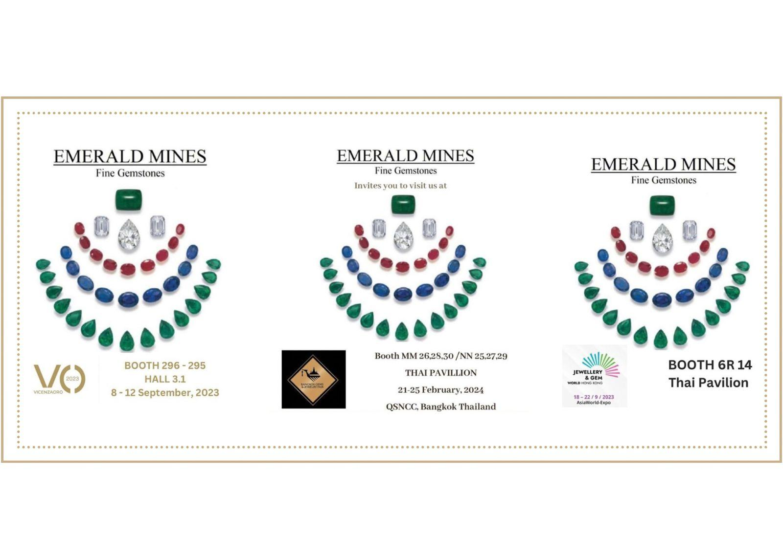

TRADE SHOW PARTICIPATION

We actively participate in various gem and jewellery shows throughout the year, ensuring we stay at the forefront of industry trends and innovations.

UPCOMING EXHIBITIONS, 2025

EXHIBITION NAME | DATE | MONTH | BOOTH NUMBER
VICENZAORO, ITALY | 4-9 | SEPTEMBER | HALL 3.1, BOOTH 272-273
72ND BGJF, BANGKOK, THAILAND | 9-13 | SEPTEMBER | NN 26, 28, 30 / PP 25, 27, 29
JGW, HONGKONG | 15-19 | SEPTEMBER | 6R14, AWE
JGT DUBAI | 11-13 | NOVEMBER | SH 14

PAST EXHIBITIONS, 2024

EXHIBITION NAME | DATE | MONTH | BOOTH NUMBER
JAS JAIPUR | 5-7 | JULY | 95
VICENZAORO, ITALY | 6-10 | SEPTEMBER | HALL 3.1, BOOTH 272-273
70TH BGJF, BANGKOK, THAILAND | 9-13 | SEPTEMBER | MM26,28,30/ NN25,27,29
JGW, HONGKONG | 16-20 | SEPTEMBER | 6R14, AWE
JGT DUBAI | 12-14 | NOVEMBER | SH 14

